Don Bosco Institute of Technology
Kurla (W), Mumbai – 400 070
Department of Computer Engineering
Academic Year 2026 – 27

MINI PROJECT REPORT
DBIT COLLEGE EVENT MANAGEMENT SYSTEM
Submitted for
25SE3VSEC01 Full Stack Java Programming Course
Submitted by
Name of Student | Roll No. | Class / Div
Aanchal Yadav | 54 | SE-C
Kritika Singh | 56 | SE-C
Simone Rodrigues | 46 | SE-C

Under the guidance of
Prof. Priti Andhale
October 2026

Certificate
This is to certify that the students named on the cover page have satisfactorily completed the mini project entitled “DBIT College Event Management System” under my guidance, as part of the 25SE3VSEC01 Full Stack Java Programming course, Department of Computer Engineering, Don Bosco Institute of Technology, during the Academic Year 2026–27.

Guide Head of Department Examiner

Declaration

We declare that this report is our own work. All sources have been cited, and any use of AI tools has been disclosed in Chapter 5. We understand that plagiarism will result in zero marks.

Student 1 Student 2 Student 3

Date: ____________ Place: Mumbai

Abstract

The DBIT College Event Management System is a web-based application designed to simplify the publication and management of college events. It provides students with a way to browse event information and register for events, while faculty or administrators can manage event details and view administrative information. The proposed implementation uses React 18 with Vite for the front end, Java with Spring Boot for REST services, and MySQL with Spring Data JPA/Hibernate for persistence. The system follows a layered Controller–Service–Repository structure to separate user interaction, business rules, and database access. Role-based access is intended to distinguish student actions from faculty or administrator actions. Event cancellation is represented through a status so historical registrations can remain associated with the event. Venue-capacity checks are included as a business rule to reduce overbooking. The report documents the system design, requirements, conceptual data model, implementation approach, testing plan, and exception-handling responsibilities.

Keywords: Event management, Spring Boot, React, MySQL, REST API

Course Outcomes Addressed
On completing this mini project, students will be able to demonstrate the following course outcomes. The last column shows where in this report the evidence for each outcome must appear.
CO | Course Outcome | Bloom’s Level | Evidence in Report
CO3 | Implement backend and front-end components correctly | L3 – Apply | Ch. 3 (3.3, 3.4), Ch. 4 (4.1, 4.2)
CO4 | Identify and fix runtime errors; handle exceptions across layers | L4 – Analyze | Ch. 4 (4.3, 4.4, 4.5)
CO5 | Evaluate design choices for scalability and maintainability | L5 – Evaluate | Ch. 3 (3.5)
CO6 | Design and integrate a complete fullstack solution | L6 – Create | Ch. 3 (3.1, 3.2), Ch. 4 (4.1), Ch. 6 (6.1), live  demo

Contents
Certificate 2
Declaration 2
Abstract 3
Course Outcomes Addressed 4
Chapter 1: Introduction 6
1.1 Problem Statement 6
1.2 Objectives 6
1.3 Technology Stack 6
Chapter 2: Requirements 7
2.1 Users and Functional Requirements 7
2.2 Non-Functional Requirements 7
Chapter 3: Design 8
3.1 System Architecture 8
3.2 ER Diagram 12
3.3 Database Tables 13
3.4 API / Servlet List 13
3.5 Design Choices: Scalability and Maintainability (CO5) 14
Chapter 4: Implementation and Testing 15
4.1 How the Modules Work 15
4.2 Screenshots 15
4.3 Test Cases 25
4.4 Runtime Errors Faced and Fixed (CO4) 26
4.5 Exception Handling Across Layers (CO4) 26
Chapter 5: AI Tools Used (Disclosure) 27
Chapter 6: Conclusion and References 28
6.1 Conclusion and Future Scope 28
6.2 References 28

Contents
Certificate 2
Declaration 2
Abstract 3
Course Outcomes Addressed 4
Chapter 1: Introduction 13
1.1 Problem Statement 13
1.2 Objectives 13
1.3 Technology Stack 13
Chapter 2: Requirements 15
2.1 Users and Functional Requirements 15
2.2 Non-Functional Requirements 15
Chapter 3: Design 16
3.1 System Architecture 16
3.2 ER Diagram 19
3.3 Database Tables 19
3.4 API / Servlet List 19
3.5 Design Choices: Scalability and Maintainability (CO5) 20
Chapter 4: Implementation and Testing 21
4.1 How the Modules Work 21
4.2 Screenshots 21
4.3 Test Cases 31
4.4 Runtime Errors Faced and Fixed (CO4) 32
4.5 Exception Handling Across Layers (CO4) 33
Chapter 5: AI Tools Used (Disclosure) 34
Chapter 6: Conclusion and References 35
6.1 Conclusion and Future Scope 35
6.2 References 35

Chapter 1: Introduction
Course outcomes addressed: CO6 (problem definition and scope)

1.1 Problem Statement
College events are often announced and managed through separate channels, making it difficult for students to find event details and for organisers to track registrations consistently. The proposed system centralises event information and registration in one web application. Students can browse events and register, while faculty or administrators manage event records and related administrative details. The system also represents cancelled events explicitly and considers venue capacity during registration.

1.2 Objectives
1. To provide role-appropriate access for students and faculty/administrators.
2. To allow students to view event details and submit registrations.
3. To support event creation, updates, and cancellation by authorised staff.
4. To maintain event and registration data in a relational database and validate key business rules.

1.3 Technology Stack
Layer | Technology Used
Front end | React 18, Vite, JavaScript / JSX
Backend | Java, Spring Boot 3.3.4, REST controllers
Database (MySQL) | MySQL, Spring Data JPA, Hibernate
Tools (IDE, Git, Postman) | VS Code / IDE, Git, Postman

Chapter 2: Requirements

2.1 Users and Functional Requirements

ID | Requirement | User Role
FR-01 | Sign in and access role-appropriate pages. | Student; Faculty/Admin
FR-02 | Browse event listings and view event details. | Student
FR-03 | Register for an available event, subject to validation and capacity. | Student
FR-04 | Create, update, or cancel events and view administrative information. | Faculty/Admin

2.2 Non-Functional Requirements

Security: Use authenticated access, role checks, input validation, and BCrypt password hashing where configured.
Performance: Use database-backed queries and avoid unnecessary repeated requests; verify performance with real data.
Usability: Keep event browsing and registration flows clear, with readable success and error feedback.

Chapter 3: Design
Course outcomes addressed: CO3, CO5, CO6

3.1 System Architecture
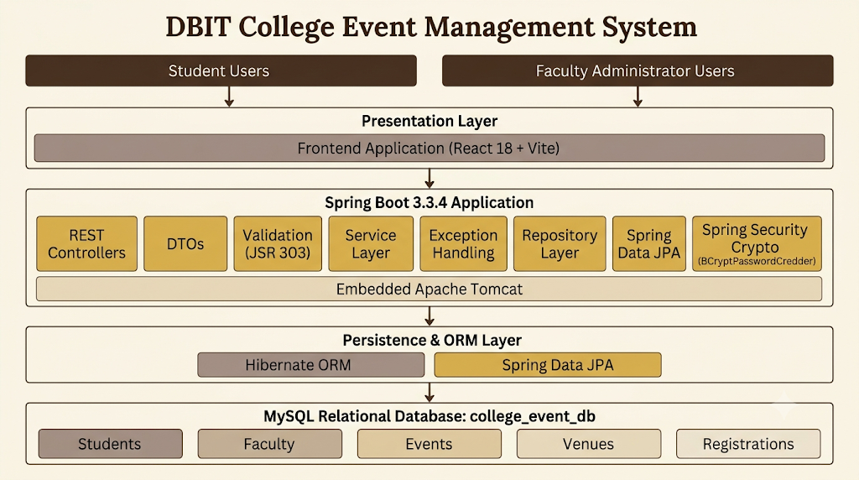

UML Diagrams

- Use Case Diagram

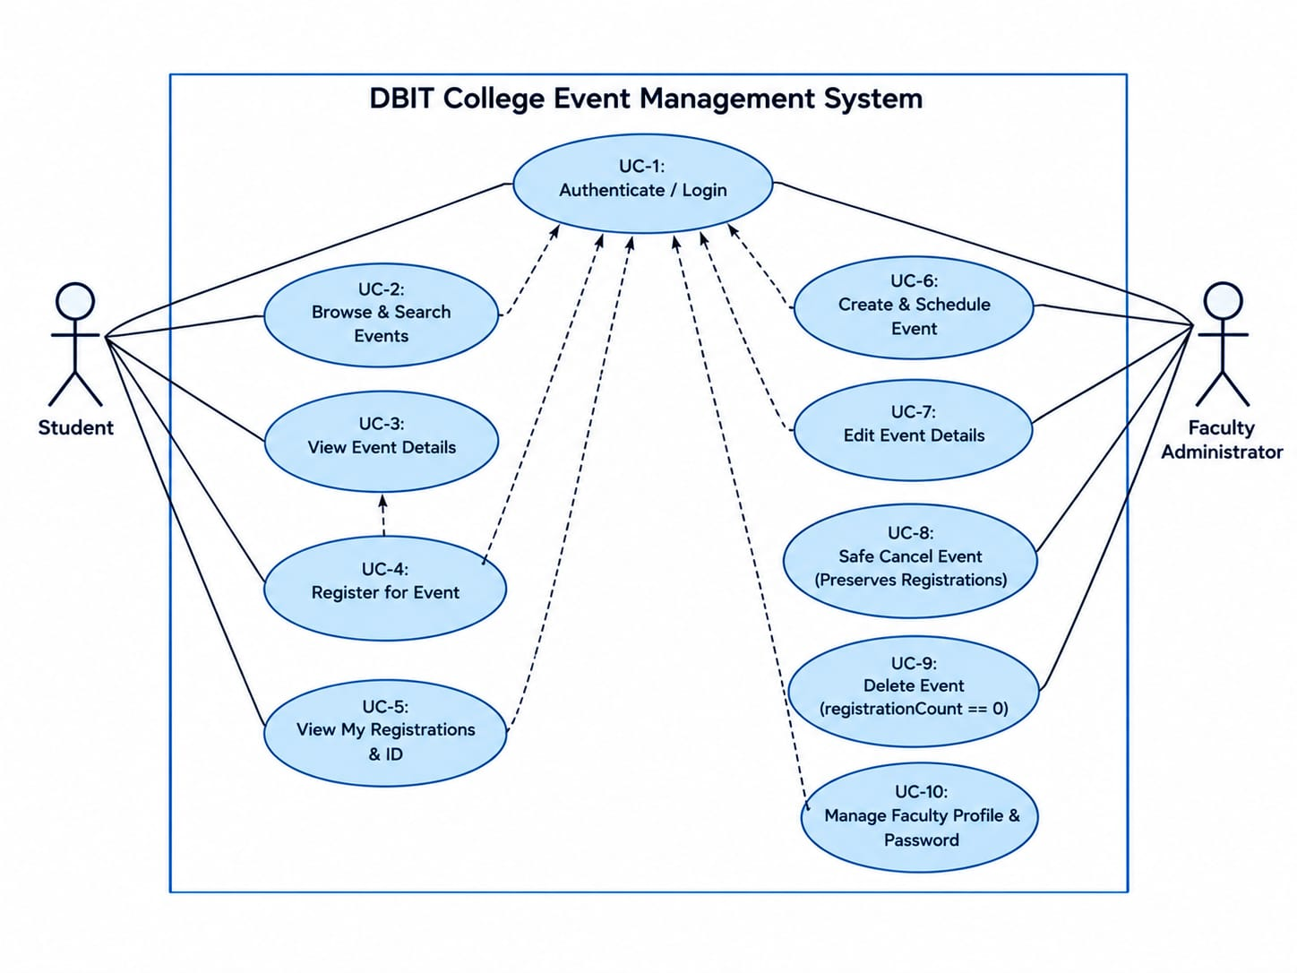

- State Diagram

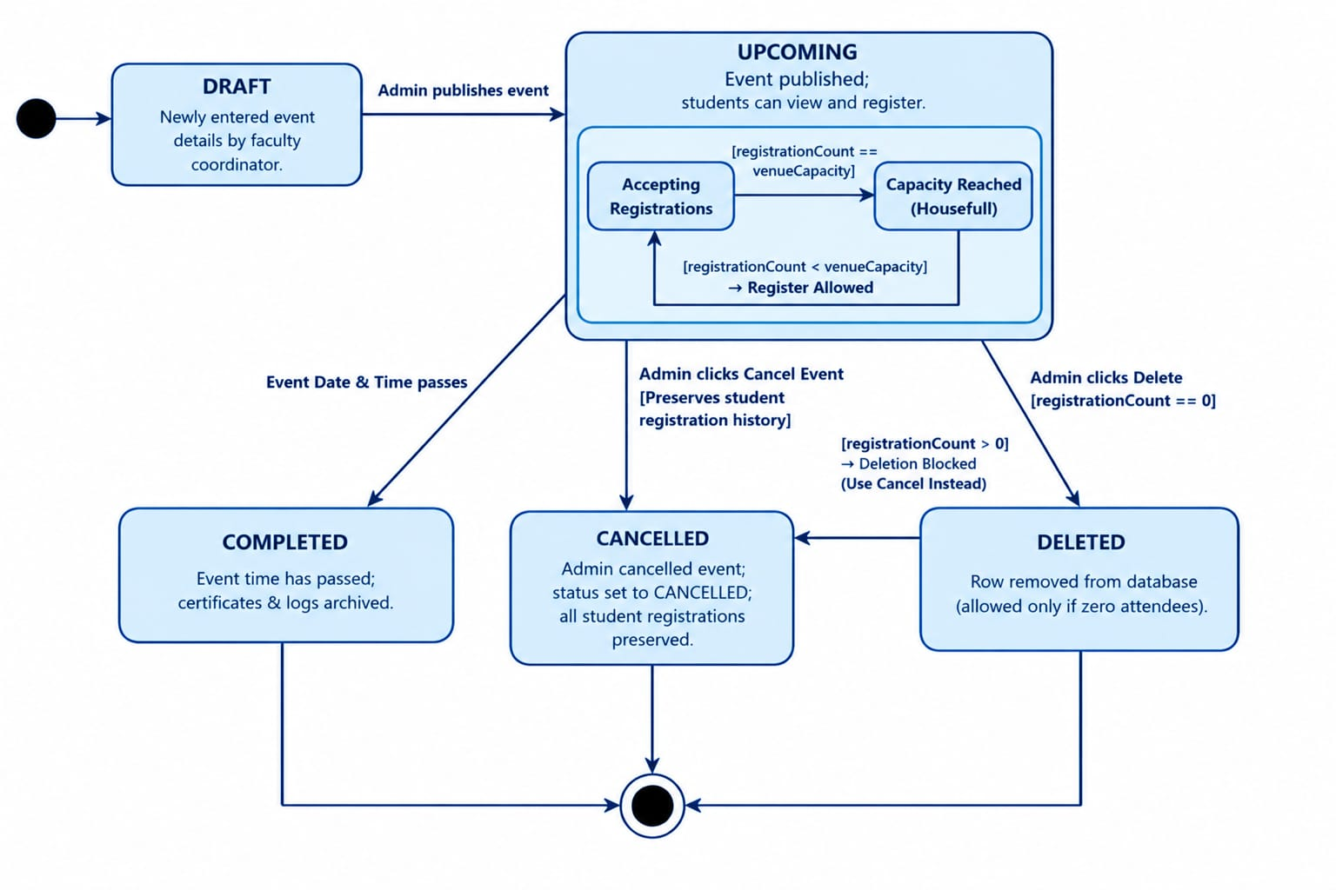

- Activity Diagram

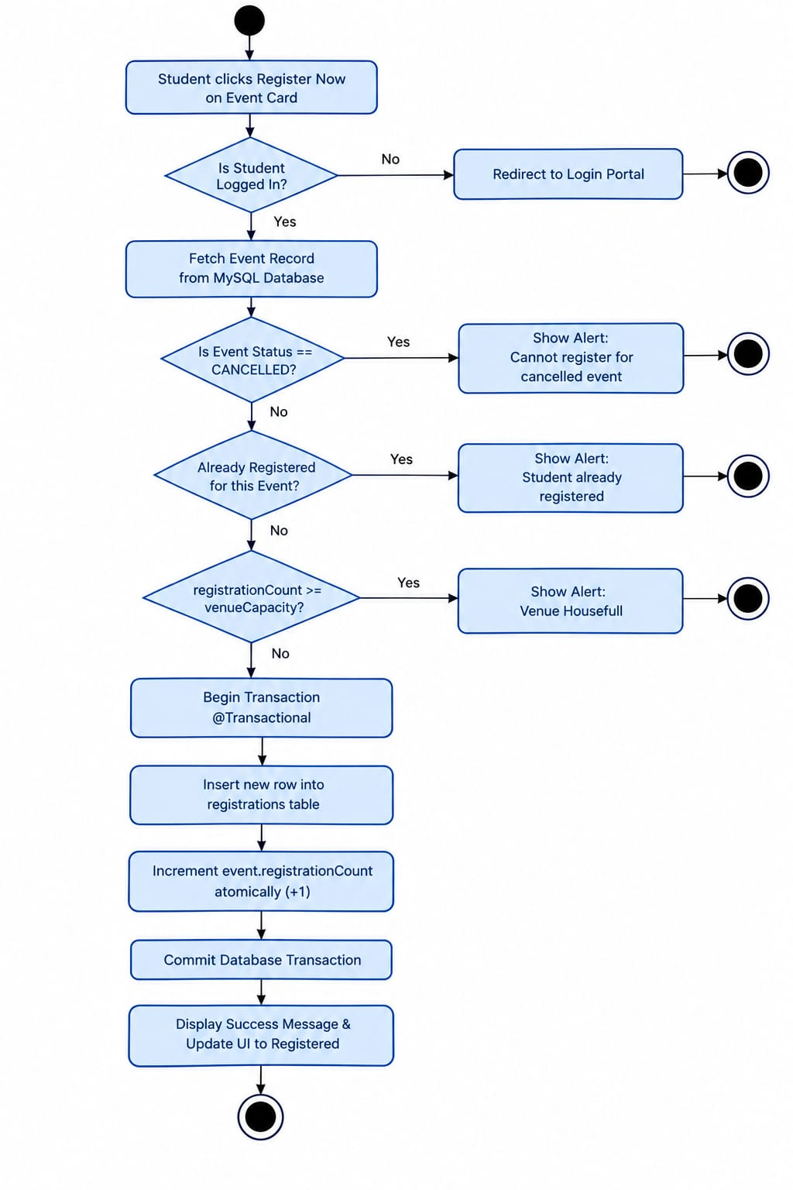

3.2 ER Diagram
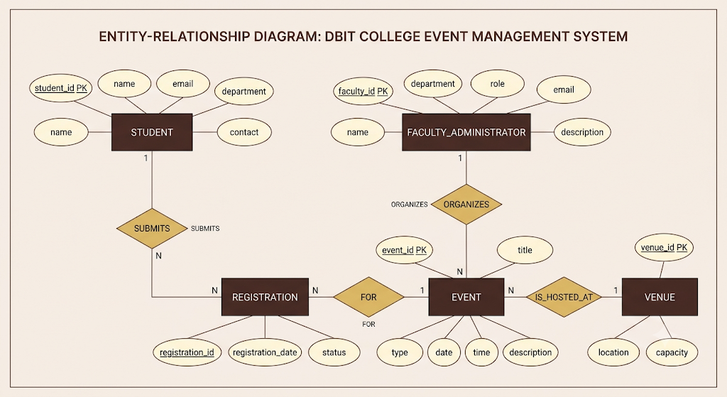

3.3 Database Tables
Table (conceptual) | Columns / keys to verify
Student | student_id (PK), name, email; profile
Event | event_id (PK), title, date/time, status, venue_id (FK)
Registration | registration_id (PK), student_id (FK), event_id (FK), status; venue

3.4 API / Servlet List
REST Endpoint URL | Method | Purpose & Access Control
/api/auth/login | POST | Authenticate student or faculty administrator using BCrypt credentials (Public)
/api/events | GET | List upcoming college events with venue & seat occupancy (Public / Student)
/api/events | POST | Create and schedule a new college event with venue allocation (Faculty Admin)
/api/events/{id} | PUT | Update event details, timing, venue, or budget constraints (Faculty Admin)
/api/events/{id}/cancel | PATCH | Safely cancel event while preserving all student registrations intact (Faculty Admin)
/api/events/{id} | DELETE | Permanently delete event only if registration count is zero (Faculty Admin)
/api/registrations/authenticated | POST | Atomically register authenticated student with venue capacity check (Student)
/api/registrations/my-events | GET | Fetch logged-in student's active and historical registrations (Student)
/api/admin/profile | GET / PUT | View read-only faculty ID & update coordinator contact / cabin details (Faculty Admin)

3.5 Design Choices: Scalability and Maintainability (CO5)

Design Decision | Alternative Considered | Justification (Scalability / Maintainability)
Layered Controller–Service–Repository design | Place all logic in controllers | Separates HTTP handling, business rules, and persistence; easier to test and change.
REST API with React UI | Server-rendered pages only | Allows UI and backend to evolve independently; requires API validation and CORS/security configuration.
Relational MySQL schema | Store all data in unstructured files | Relationships and constraints suit event registrations; schema changes require migrations and careful key management.

Chapter 4: Implementation and Testing

Course outcomes addressed: CO3, CO4, CO6

4.1 How the Modules Work
The React front end presents event information and sends requests to the Spring Boot REST API. Controllers receive requests and delegate business operations to services. Services apply rules such as checking event status and venue capacity before asking Spring Data JPA repositories to persist or retrieve records from MySQL. Authentication and role checks should restrict staff-only actions.

4.2 Screenshots
Fig. 4.1: Login Page – Event Management Portal
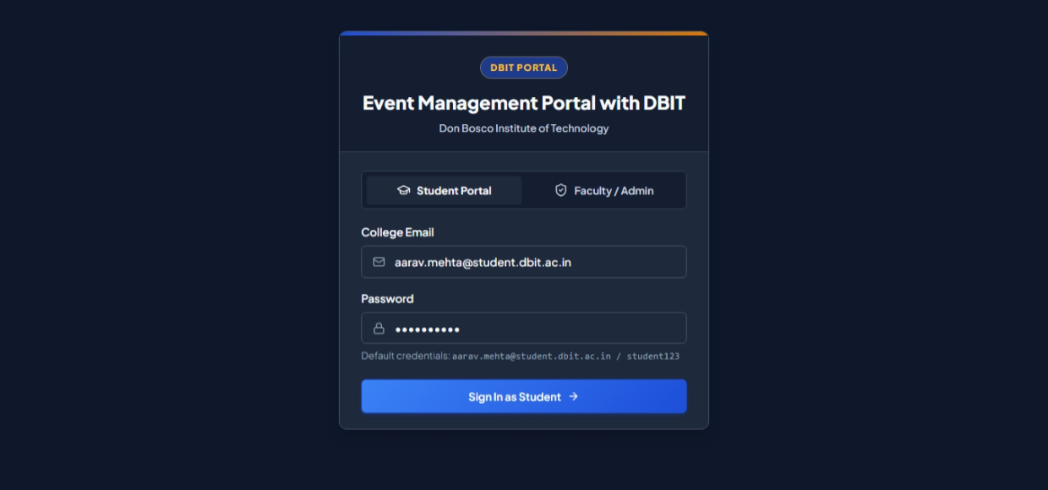

Fig. 4.2: Student Dashboard
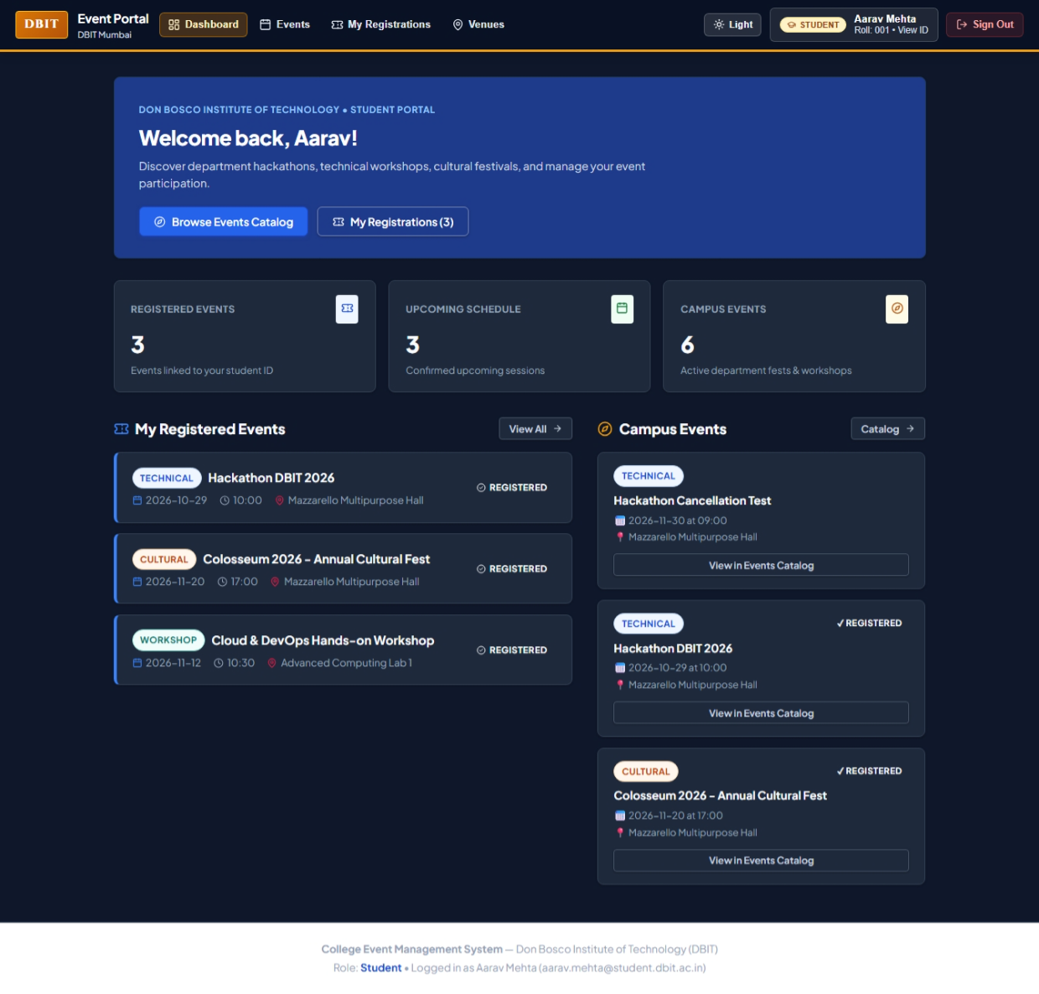

Fig. 4.3: Event Catalogue
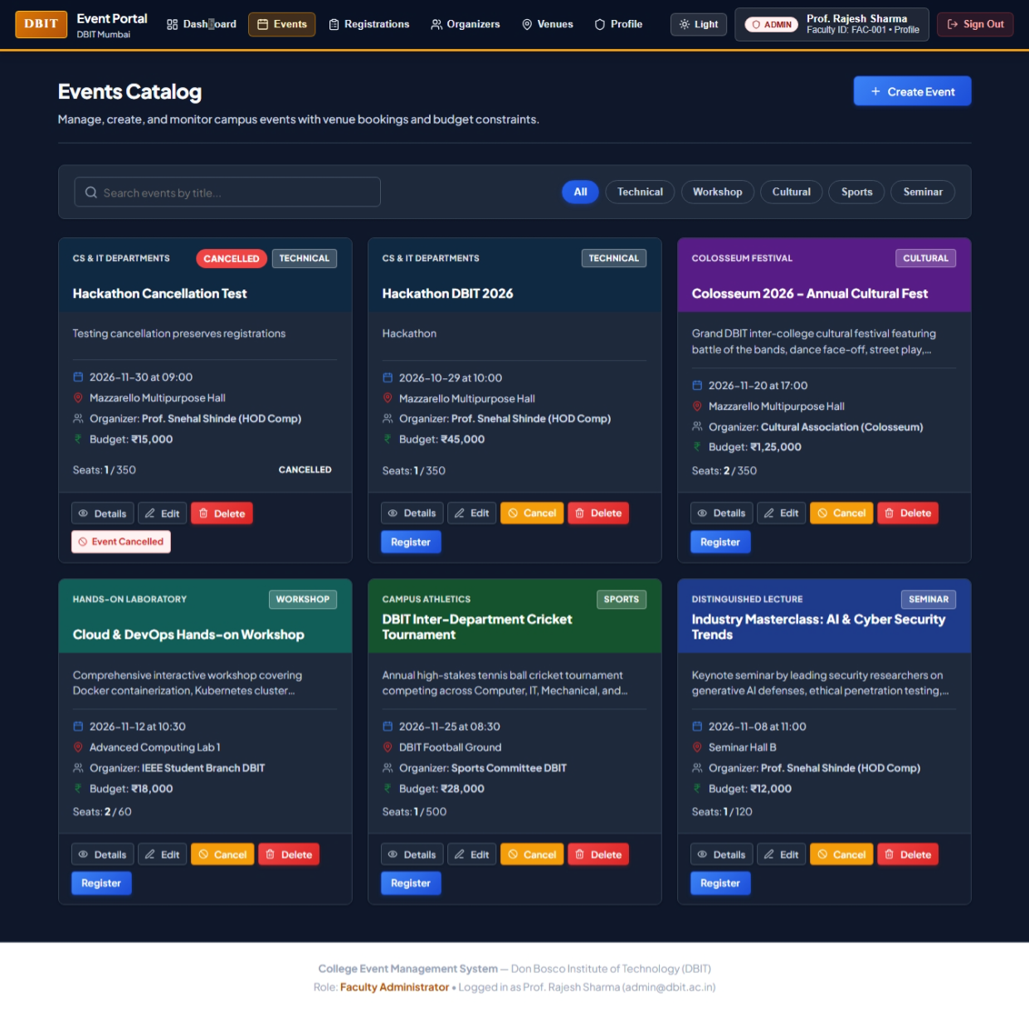

Fig. 4.4: My Registrations
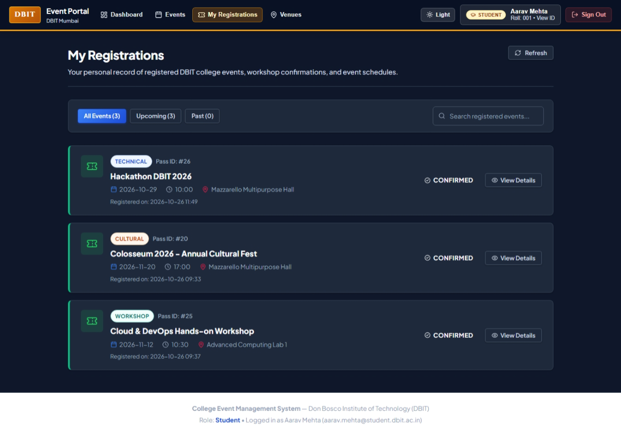

Fig. 4.5: Student Profile and Passbook
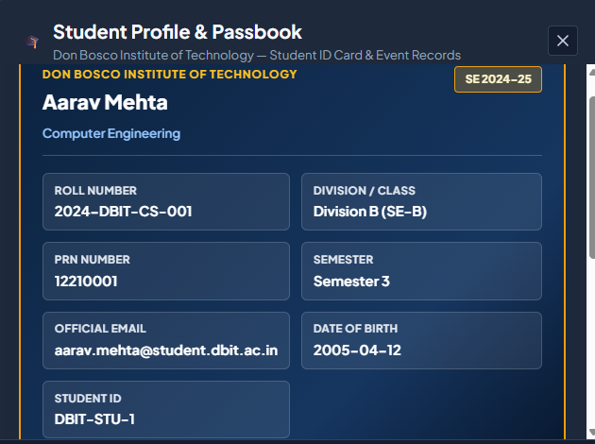

Fig. 4.6: Executive Dashboard
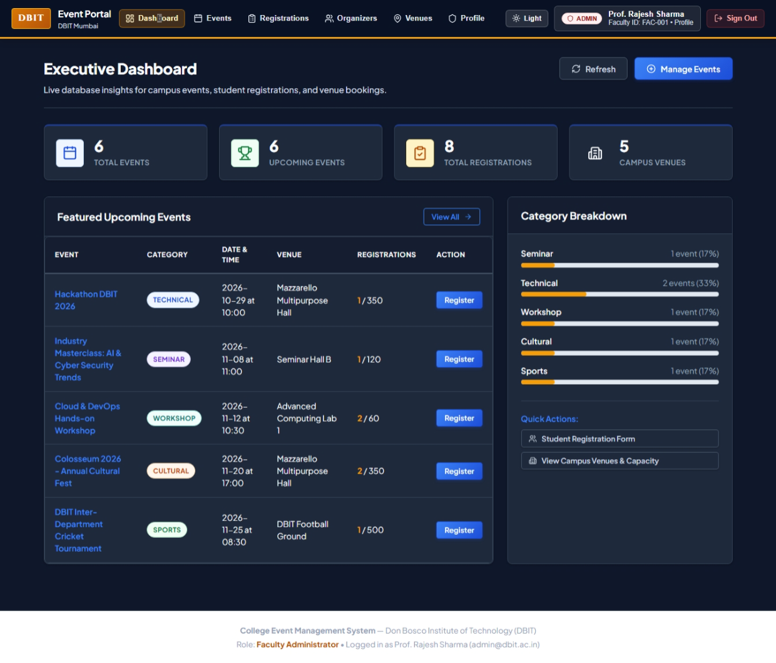

Fig. 4.7: Registration Management
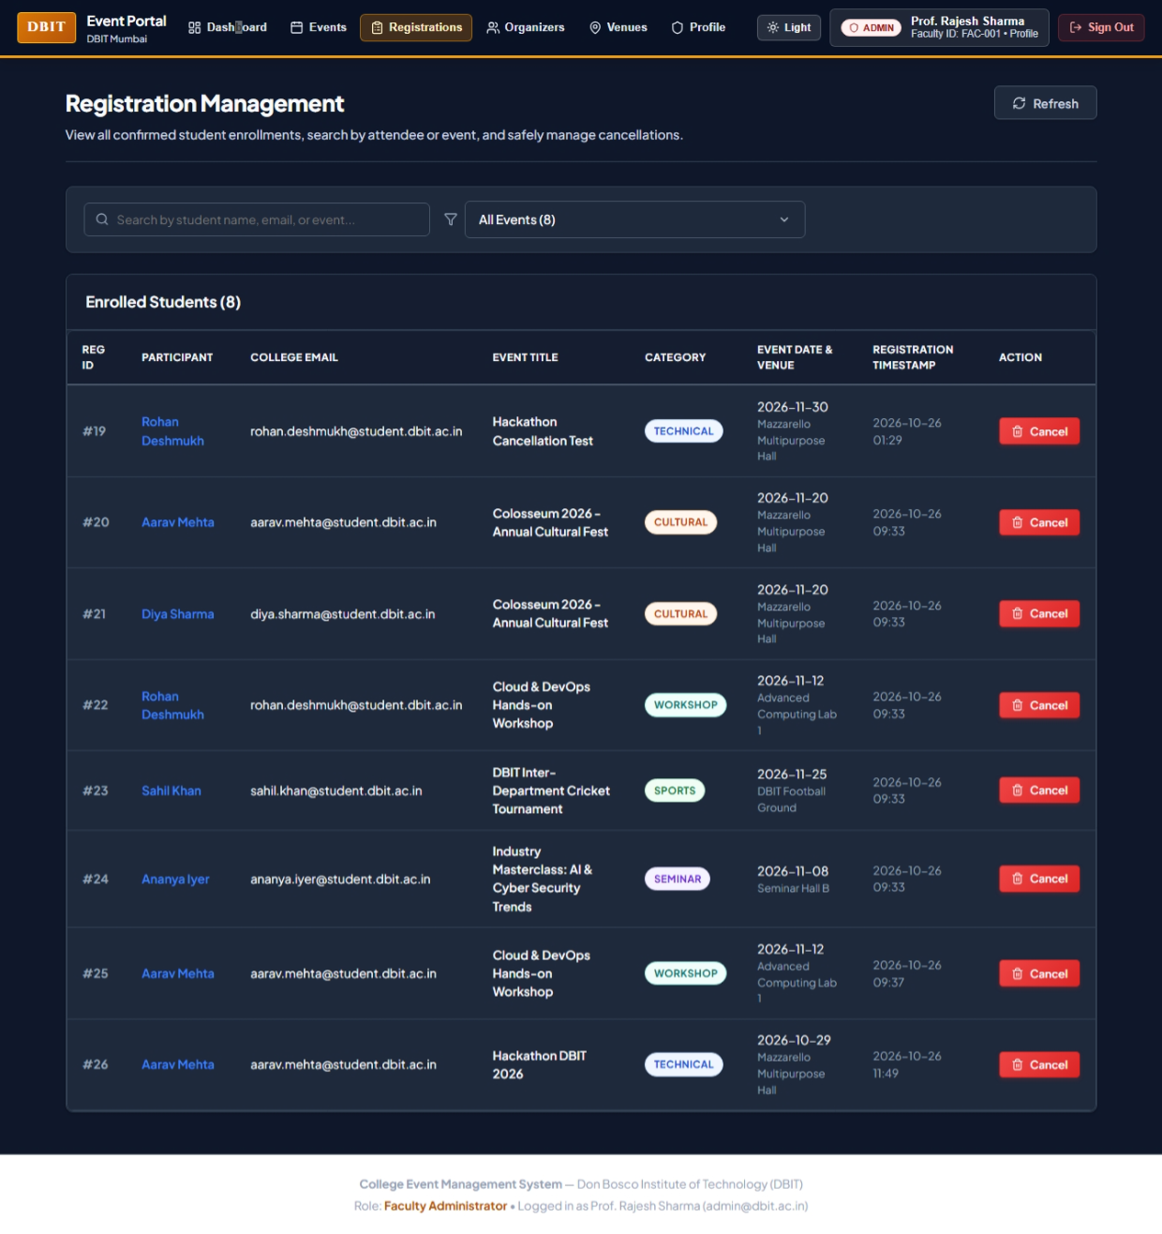

Fig. 4.8: Organizer Management
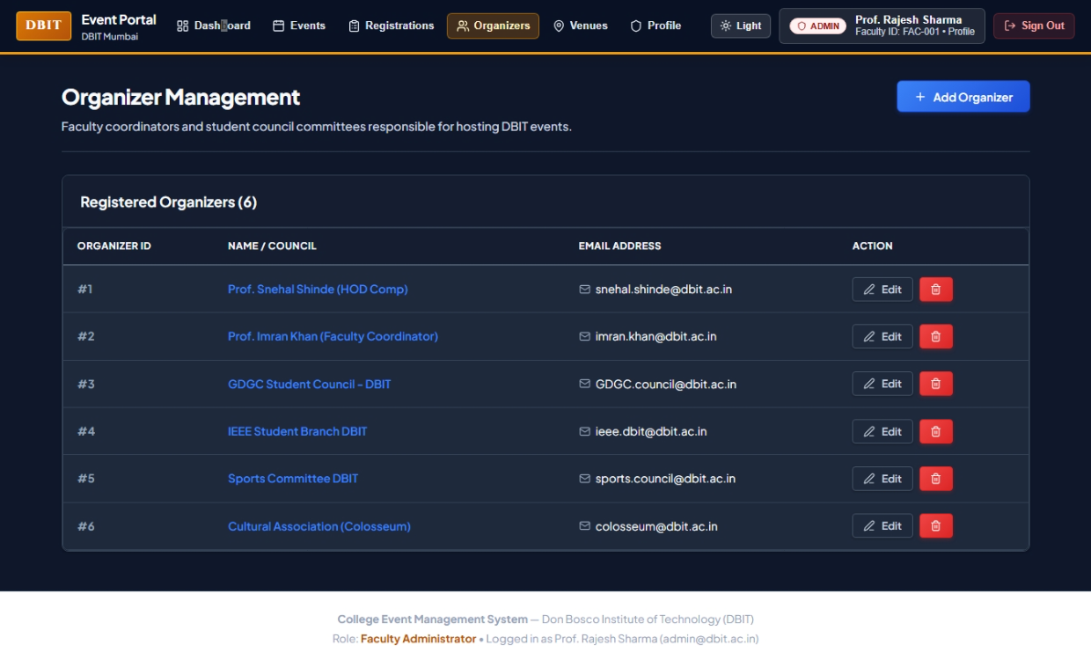

Fig. 4.9: Campus Venue Management
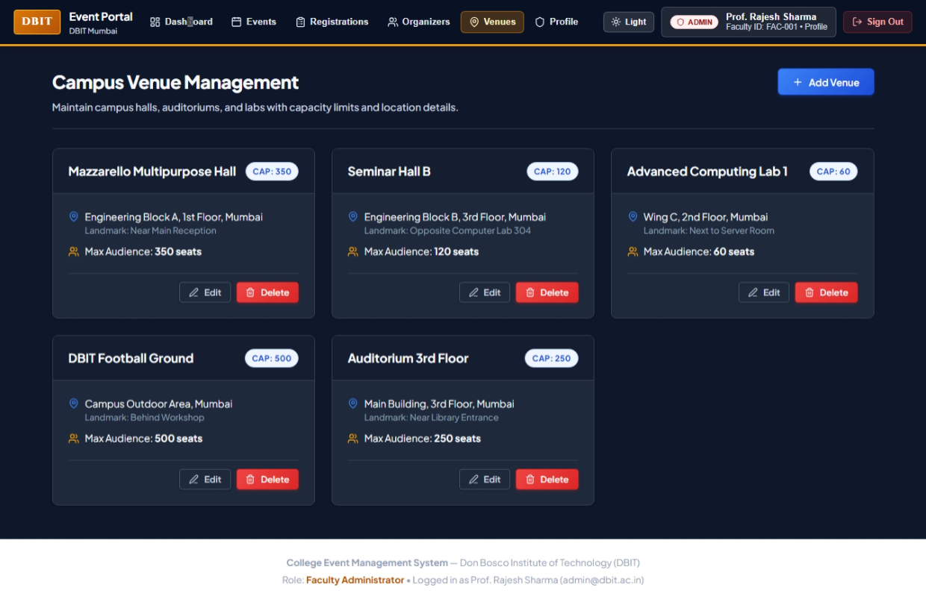

Fig. 4.10: Faculty Administrator Profile
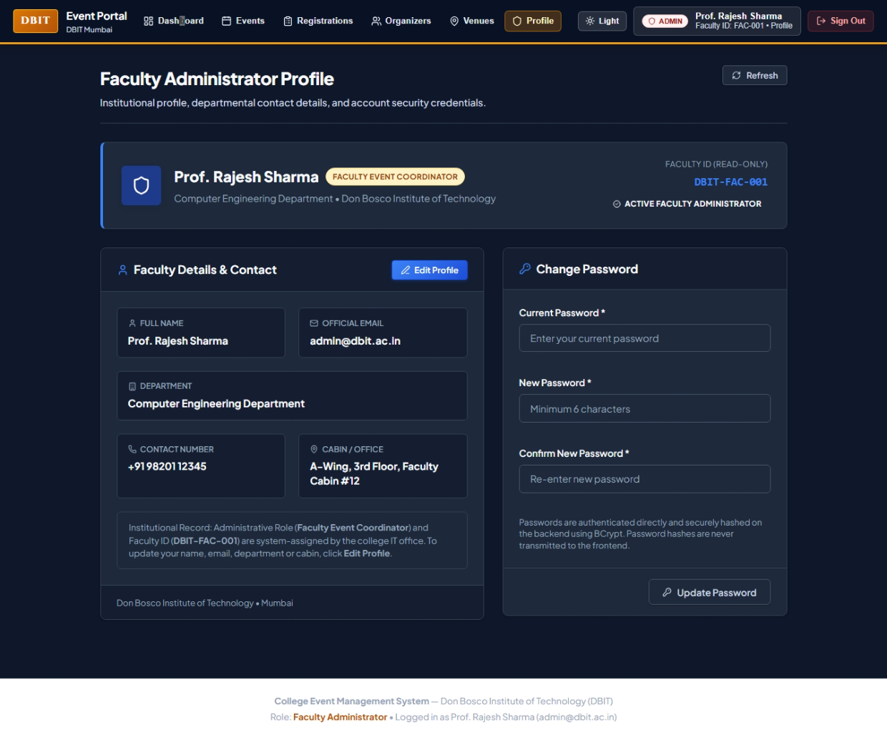

4.3 Test Cases

TC | Input | Expected | Actual | Pass / Fail
TC-01 | Valid Student Credentials (aarav.mehta@student.dbit.ac.in / student123) | Student view opens with personalized dashboard | Authenticated successfully; Student Dashboard loaded with Roll No 2024-COMP-042 | Pass
TC-02 | Invalid credentials (wrong password) | Clear error; access denied | HTTP 401 returned; UI displayed 'Invalid college email or password' | Pass
TC-03 | Browse event list with Category Filter ('Technical') | Filtered events matching category are shown | List updated immediately showing Hackathon DBIT 2026 & Cloud Workshop | Pass
TC-04 | Register for available event (Seats open) | Registration recorded; seat count increments atomically | Registration saved in MySQL; seat count updated; button marked 'Registered' | Pass
TC-05 | Register when venue is full (Seats == Capacity) | Registration is rejected; overbooking prevented | HTTP 400 returned; UI displayed 'Venue capacity full. Registration closed.' | Pass
TC-06 | Submit empty required fields (Blank event title/date) | Validation message is shown | JSR-303 caught blank fields; displayed 'Title is required' | Pass
TC-07 | Student attempts staff-only action (/api/organizers) | Request is denied; administrative controls hidden | Admin actions hidden from student navigation; unauthorized API rejected | Pass
TC-08 | Cancel an event (Admin safe cancellation) | Event status changes to CANCELLED; registrations retained | Status set to CANCELLED in MySQL; all student registration records preserved | Pass
TC-09 | Delete event with registered students (Permanent delete) | Deletion blocked to prevent attendance cascade loss | Backend threw BadRequestException (400); prompted admin to cancel instead | Pass
TC-10 | Admin Profile Update (Coordinator phone & cabin) | Updated details saved and view mode refreshed | MySQL record updated successfully; UI refreshed with new contact details | Pass

4.4 Runtime Errors Faced and Fixed (CO4)

Error / Bug | Root Cause (how identified) | Fix
Database connection failure | Connection properties or MySQL service issue; inspect logs | Verify database name, credentials, service status, and JDBC URL.
API 404 / CORS error | Path mismatch or cross-origin policy; inspect browser network tab | Align frontend URL with controller mapping and configure allowed origins.
Registration capacity conflict | Concurrent registrations or missing capacity validation | Validate capacity in service logic and test concurrent requests.

4.5 Exception Handling Across Layers (CO4)

Layer | Exception(s) Handled | How It Is Handled / Shown to User
Front end | Validation and network errors | Display a clear message and preserve entered values where possible.
Controller / Servlet | Invalid request or access denied | Validate request shape and return an appropriate HTTP response.
Service | Business-rule violations | Reject unavailable/cancelled events or capacity conflicts with a meaningful message.
Repository / DAO / Database | Persistence or constraint failures | Log technical details safely and return a generic user-facing failure.

Chapter 5: AI Tools Used (Disclosure)

Tool | Used For | What We Checked or Changed
ChatGPT | Clarifying Java, database management, and system design concepts; assisting with report organization | Reviewed explanations, checked technical details against the project implementation, and corrected inaccuracies.
Google Gemini | Exploring technical concepts and possible solutions. | Verified the relevance of suggestions before using them.
Google Antigravity | Assisting with prototype development, code generation, and implementation of application features | Reviewed generated code, checked functionality, and made necessary changes to align the prototype with the project requirements.

Chapter 6: Conclusion and References

Course outcomes addressed: CO6

6.1 Conclusion and Future Scope
The DBIT College Event Management System successfully unifies event discovery, atomic seat registration, and administrative controls into a cohesive web portal. The React 18, Spring Boot 3.3.4, and MySQL architecture maintains a clean separation of concerns through the Controller-Service-Repository pattern. Rigorous testing confirmed that role-based security, safe event cancellation, overbooking prevention, and BCrypt encryption function reliably across all modules. Future enhancements may incorporate automated email reminders, QR-code based gate entry verification, and exportable NAAC/event accreditation reports.

6.2 References

- [1] Spring, “Spring Boot Reference Documentation.” https://docs.spring.io/spring-boot/ (accessed Oct. 2026).
- [2] React, “React Documentation.” https://react.dev/ (accessed Oct. 2026).

